Q11. Using a terminal, connect to a remote machine via SSH and telnet.

Using SSH:

ssh [user@192.168.1.100](mailto:user@192.168.1.100)

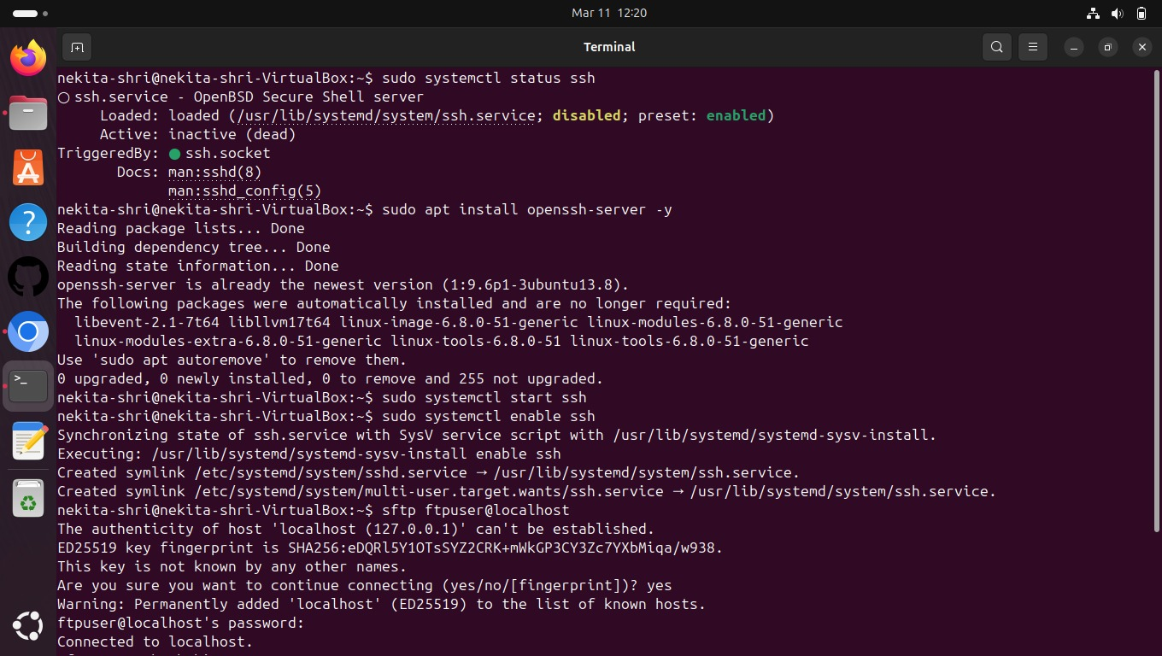

Using Telnet:

telnet <destination ip>

